WILDCARDS PART ONE

A wildcard is a character or string used for pattern matching

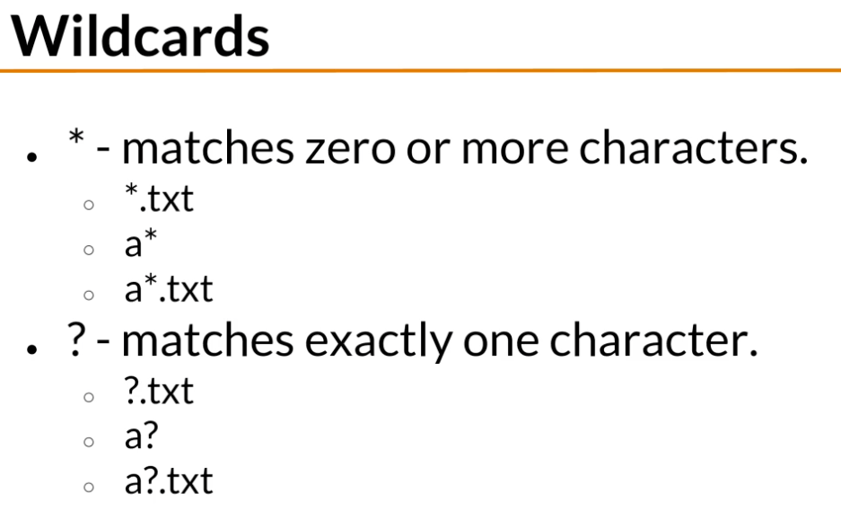

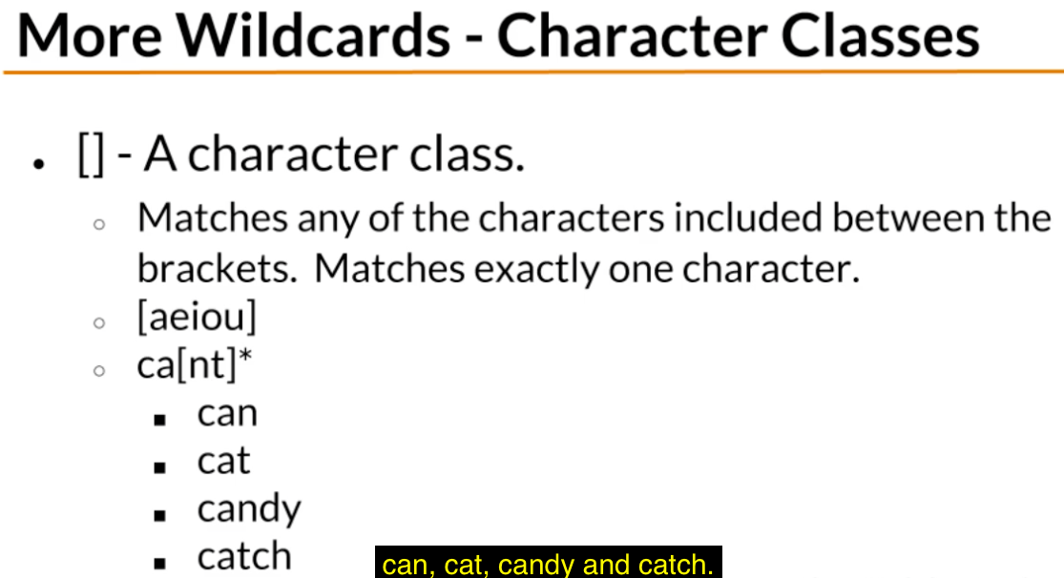

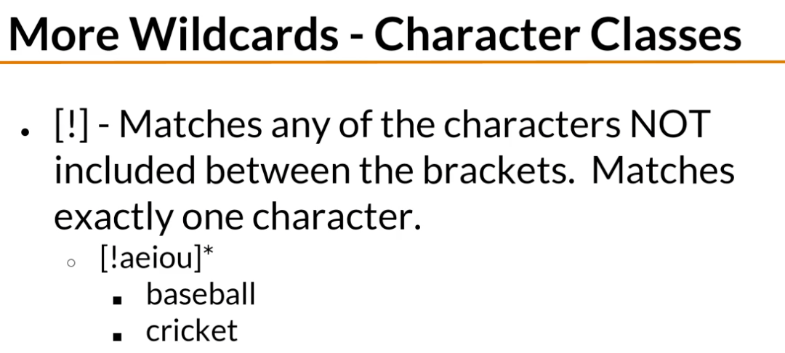

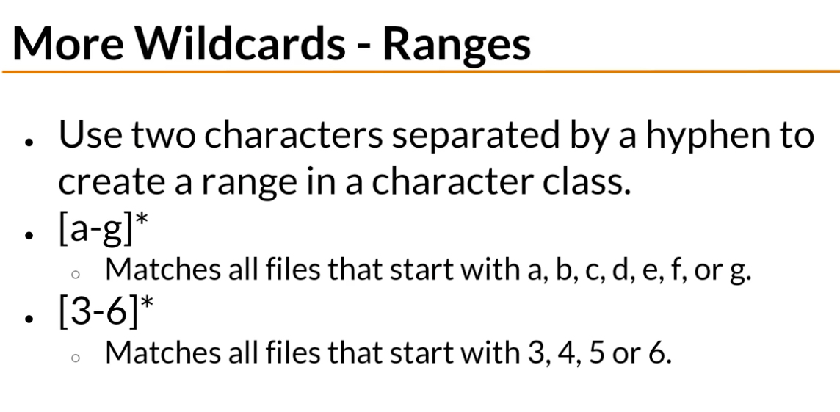

Named character classes are used as ranges too. Alpha looks for upper/lower case letters . alnum looks for upper and lowercase letters and also digits. Digit looks for numbers. Lower looks for lowercase letters. Space looks for blanks. Upper looks for uppercase letters.

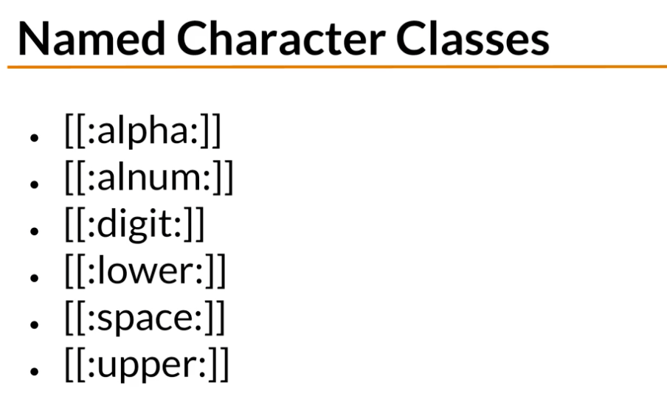

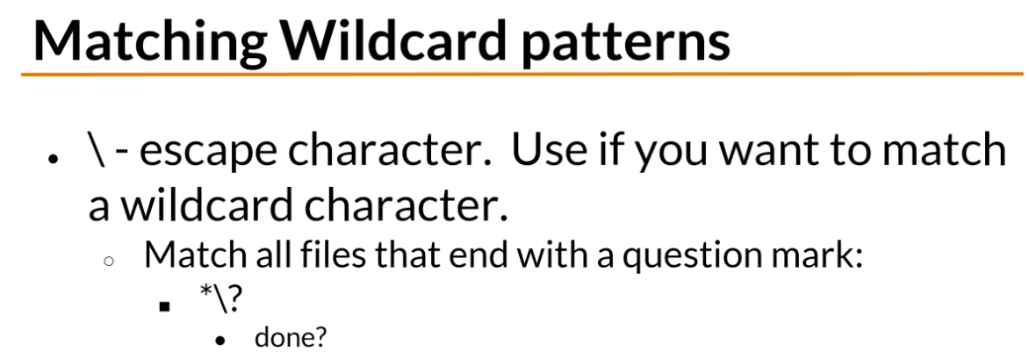

INPUT OUTPUT AND REDIRECTION

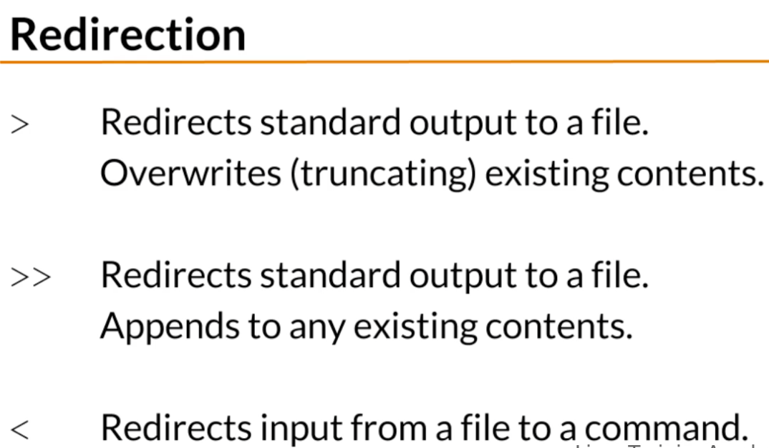

COMPARING FILES

diff and sdiff do the same thing, the only difference is that sdiff shows the files side y side

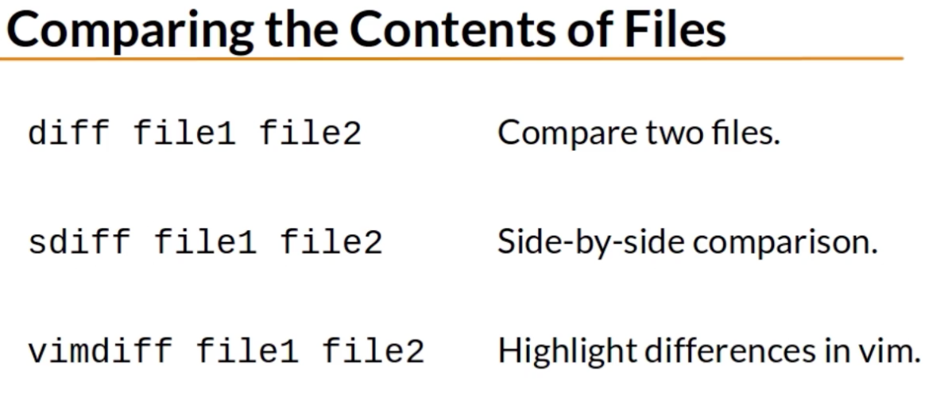

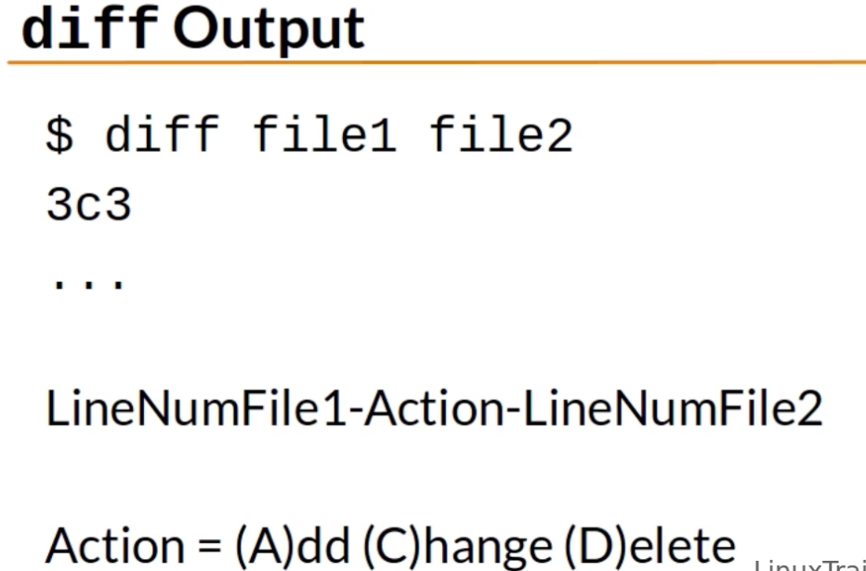

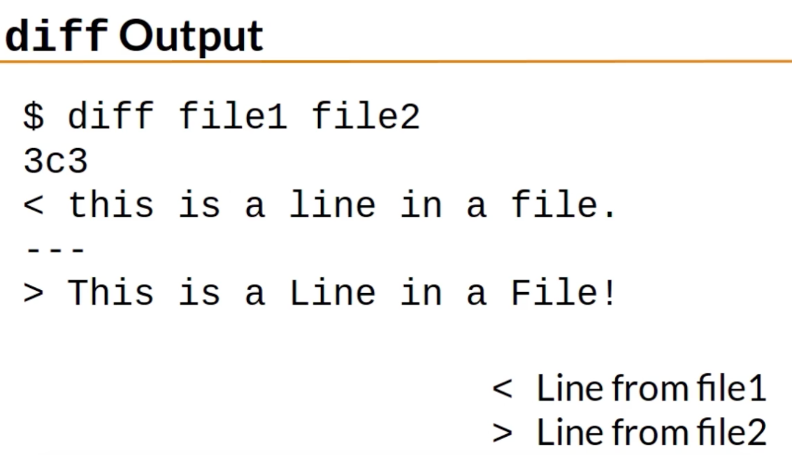

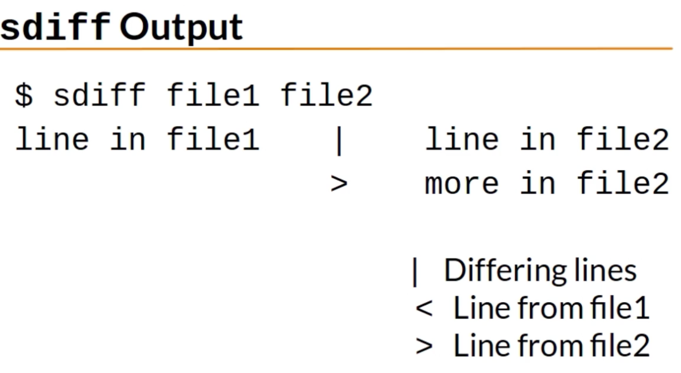

SEARCHING FILES AND USING PIPES

To look for text within a file use the “ grep ” command

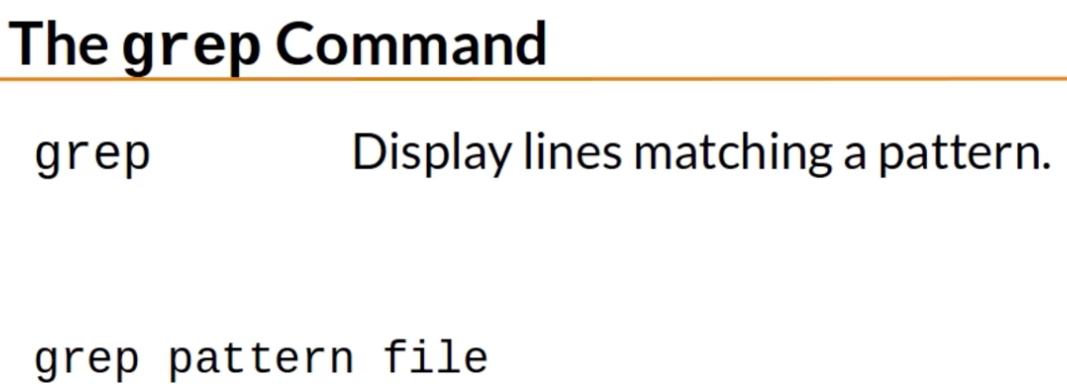

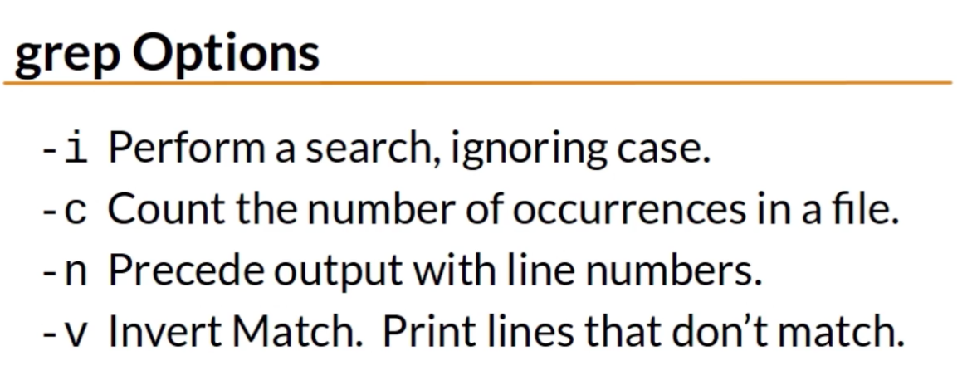

To know what a file type is for a specific file run the “ file ” command

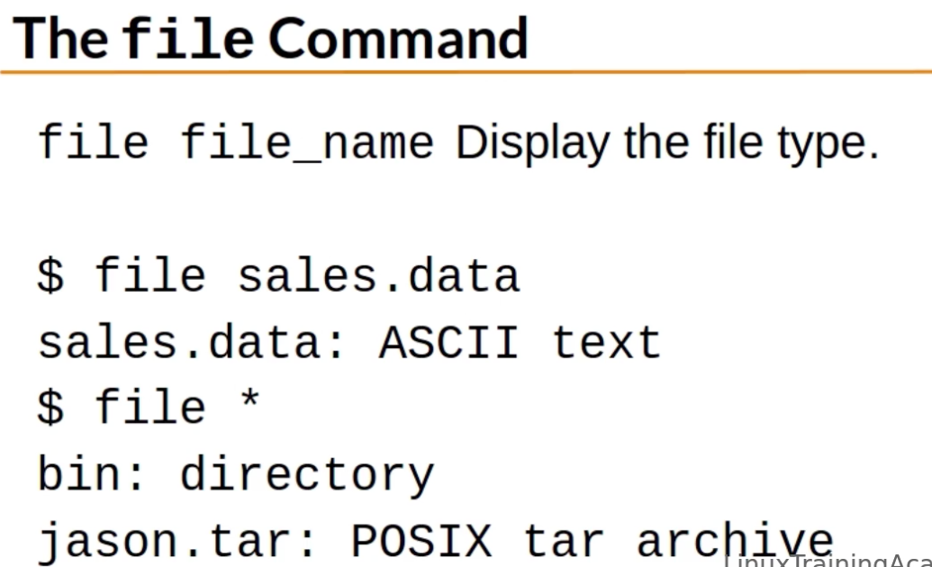

To display a binary file as readable strings use the “ strings ” command

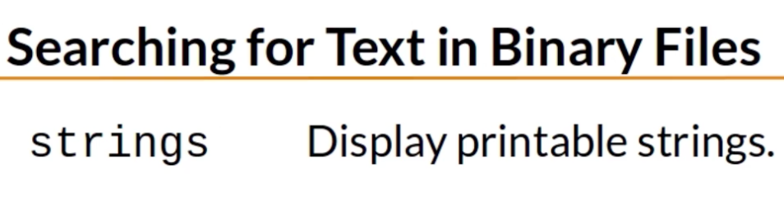

Pipe takes the standard output of the preceding command and serves it as standard input for the following command

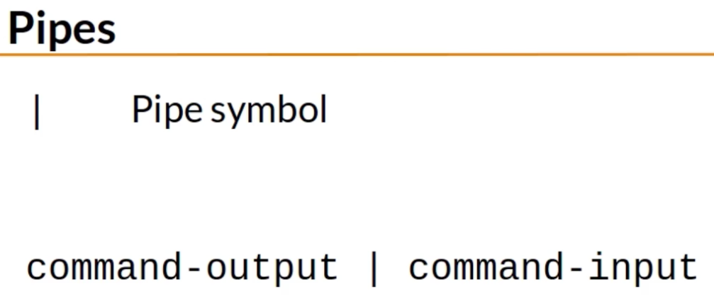

You can translate characters with the “ tr ” command

You can cut specific output using the “ cut ” command

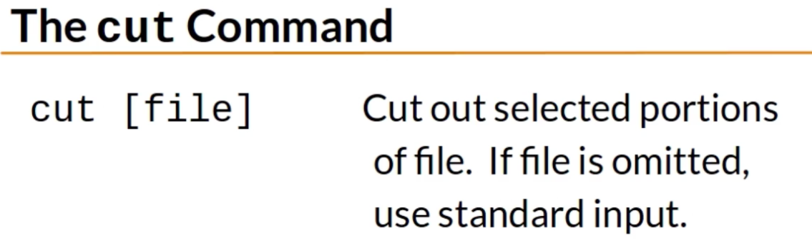

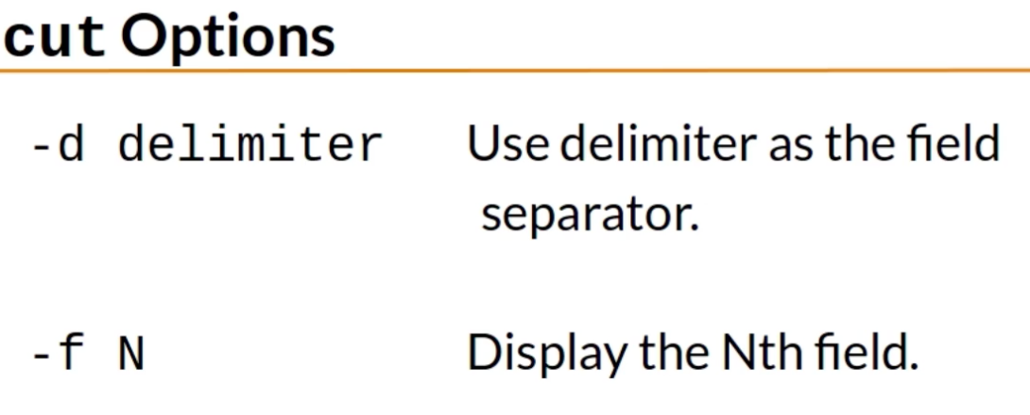

TRANSFERRING AND COPYING FILES OVER A NETWORK

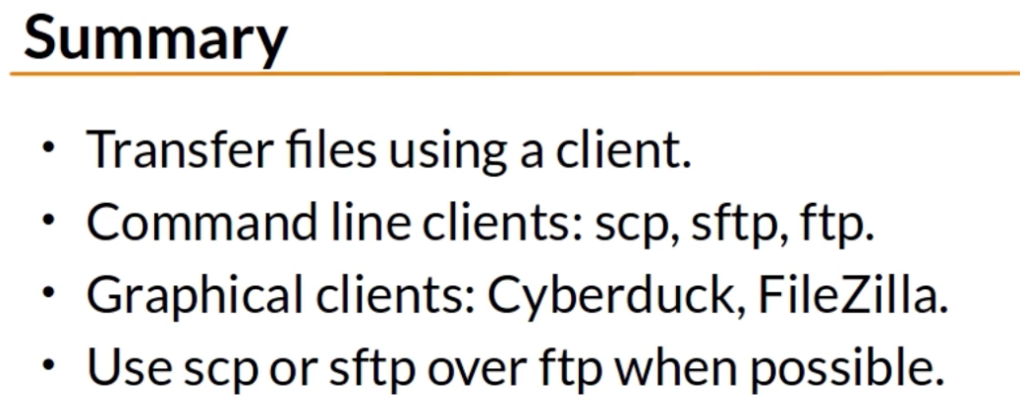

ENVIRONMENT VARIABLES

You can use the following commands to see the contents of environment variables

* printenv
* echo

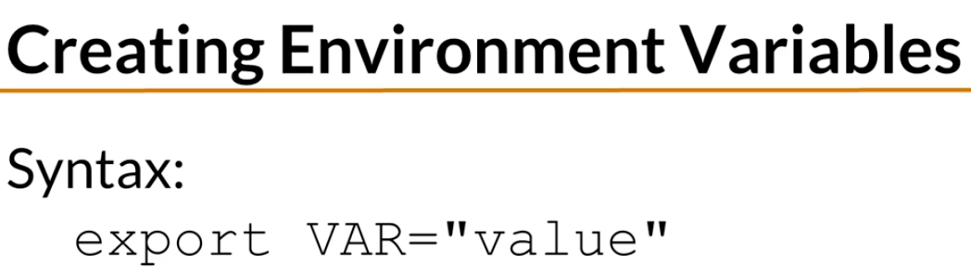

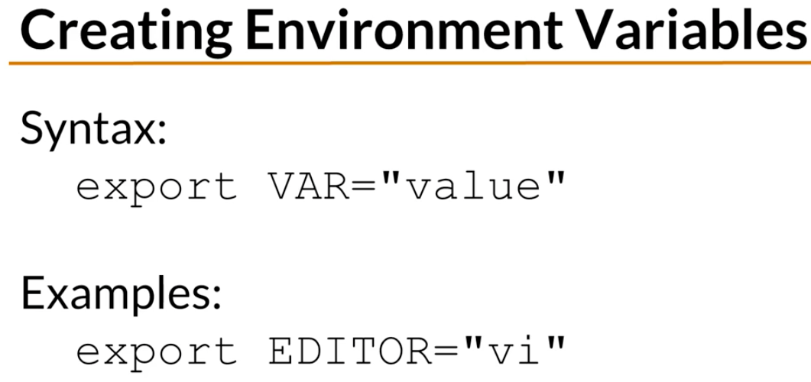

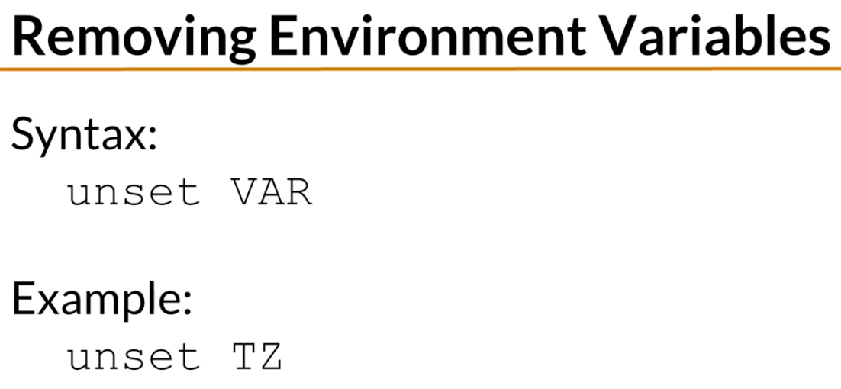

PROCESSES AND JOB CONTROL

When starting a process in the background two things are shown

* The first number is the job number
* The second number is the pid (process id)

The + sign in the job represents the current job, while the – sign represents the previous job

The current job is considered to be the last job that was stopped while being in the foreground or the last job that started in the background

jobs %+

* Command to see the current job

jobs %-

* Command to see the last job

You can kill processes by job number or by pid

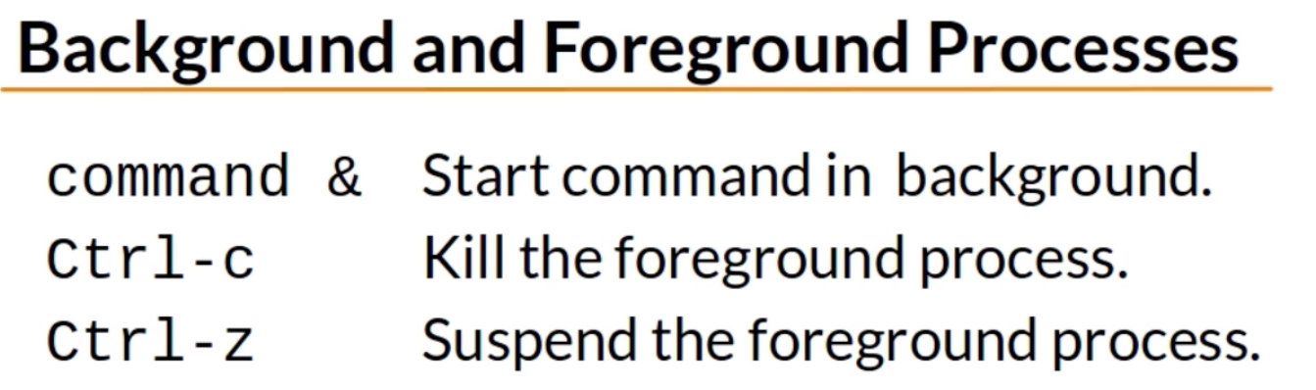

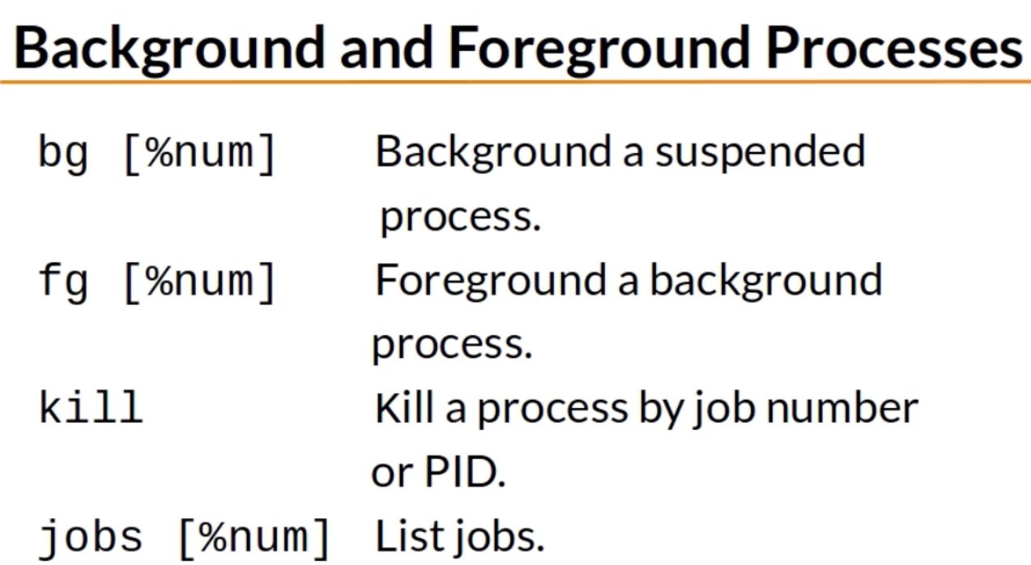

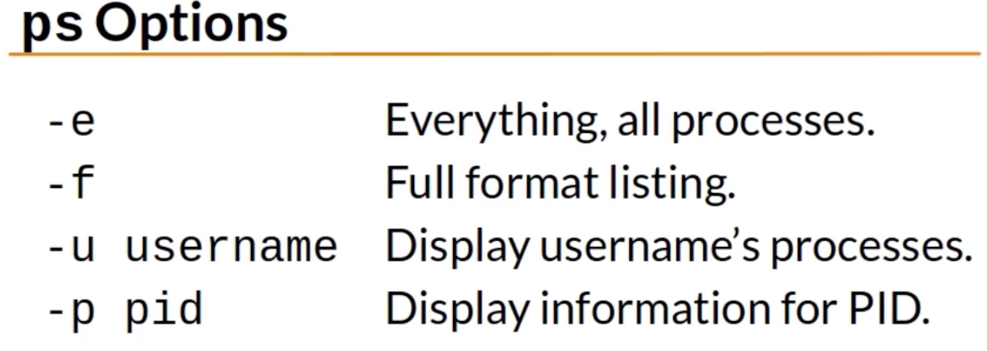

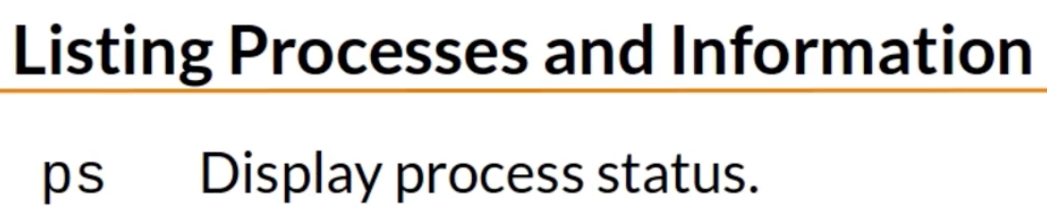

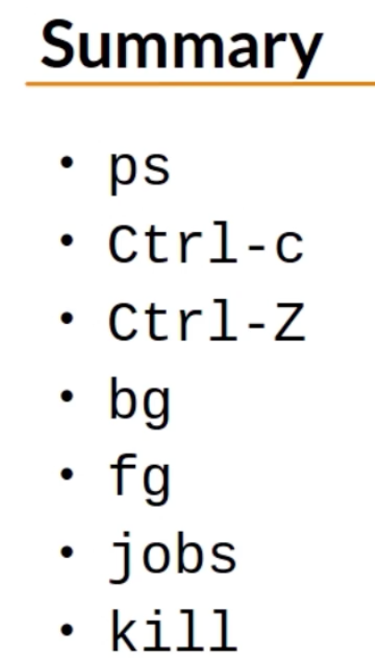

SCHEDULING REPEATED JOBS WITH CRON

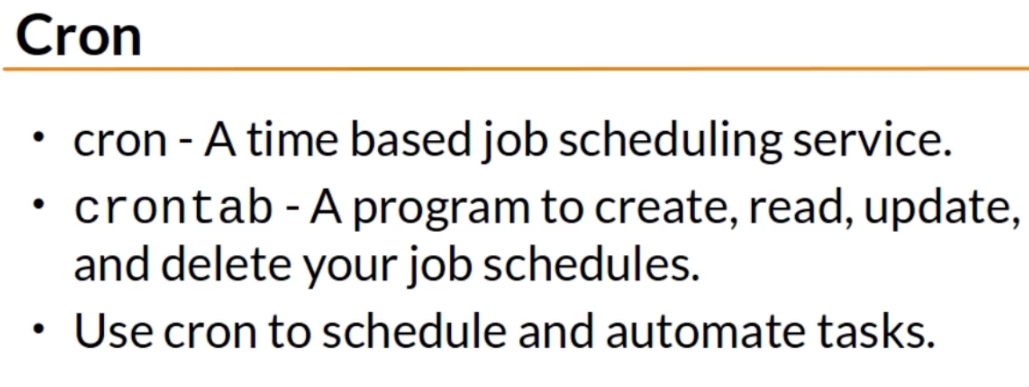

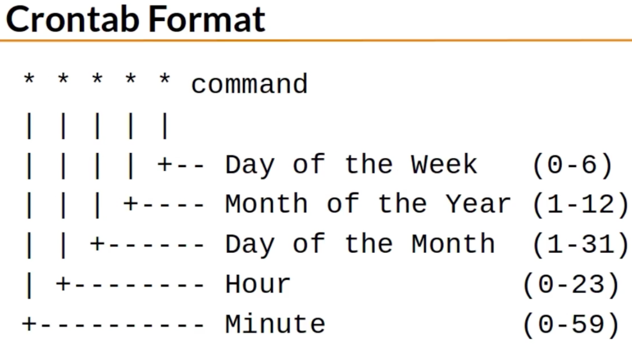

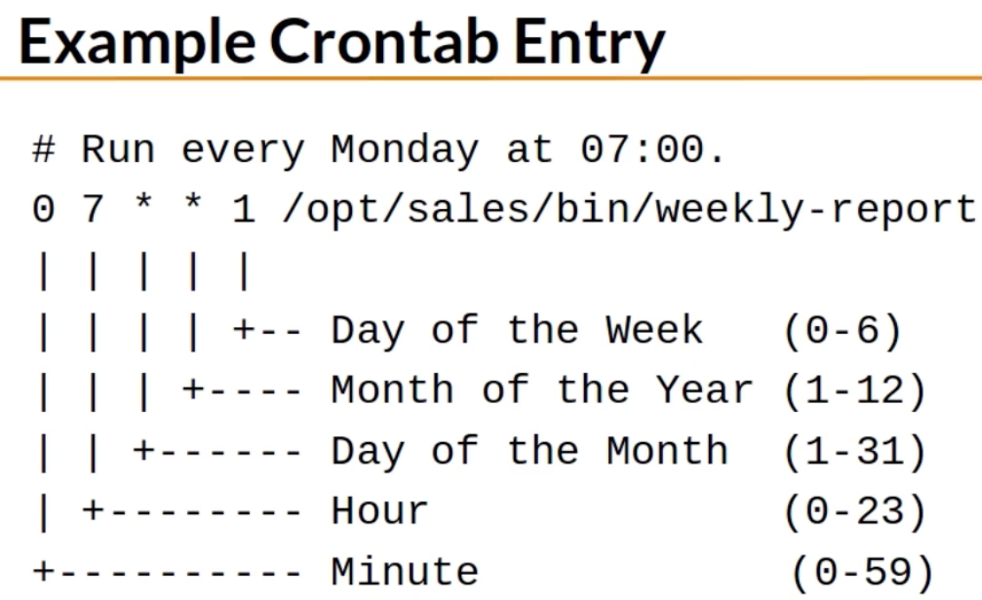

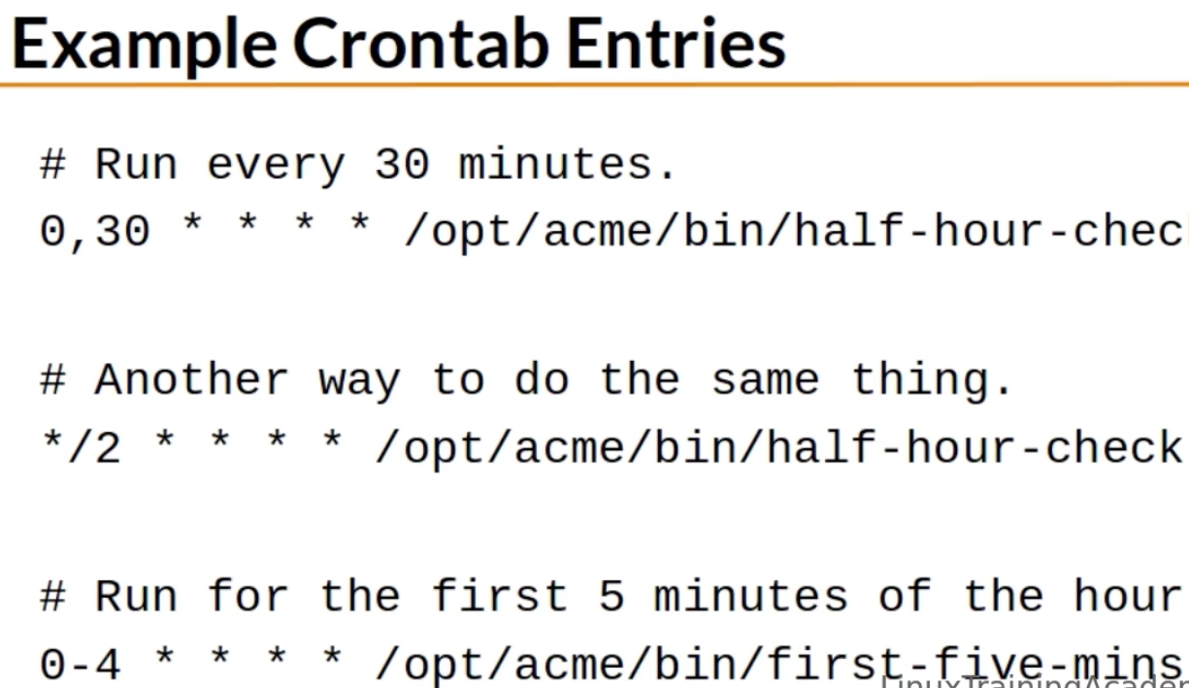

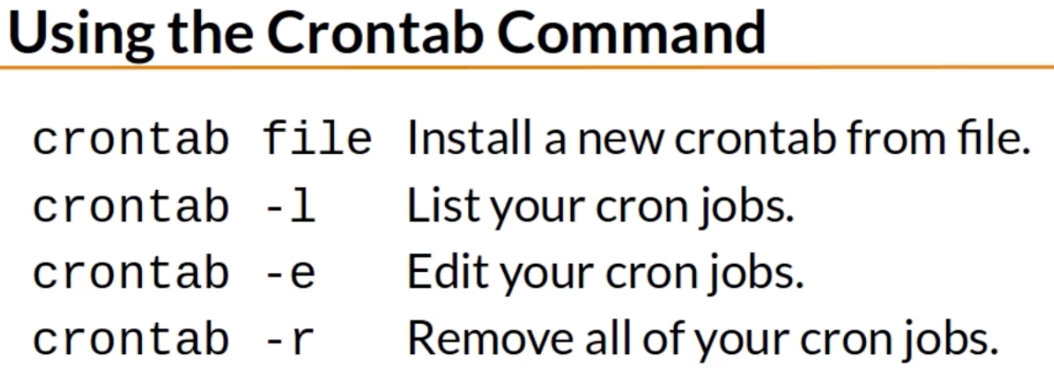

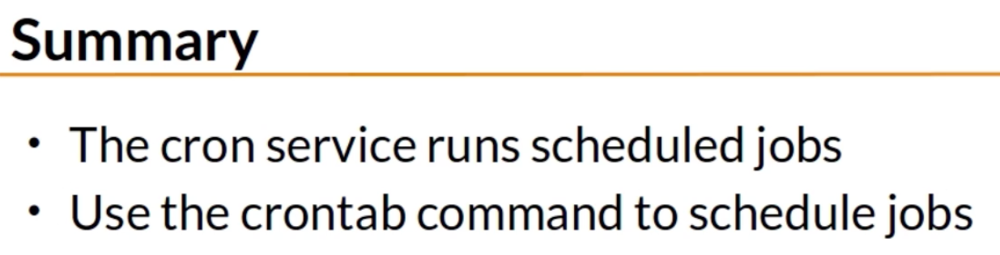

SWITCHING USERS AND RUNNING COMMANDS AS OTHERS

When no hyphen is provided to command, your current environment passes to the user you specify, so you are logged in as another user but with your same environment

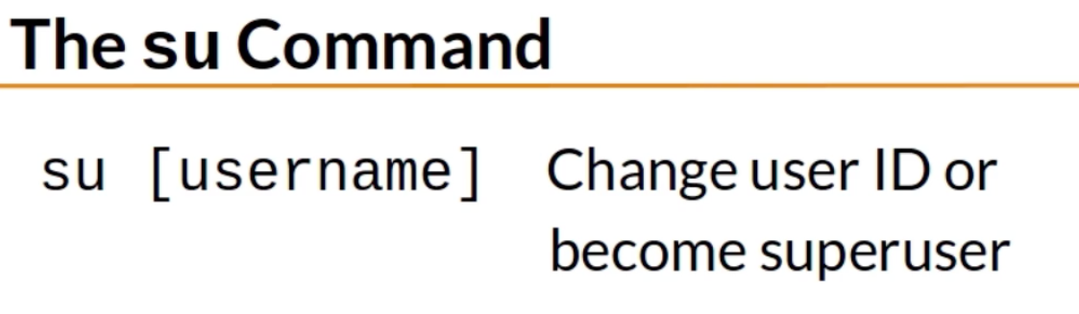

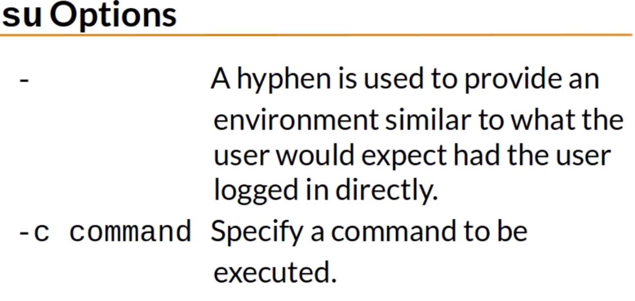

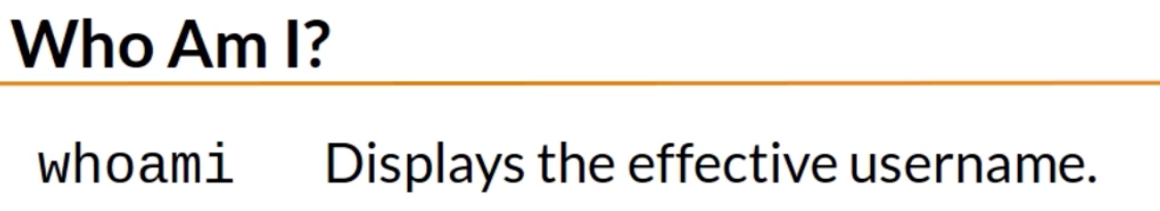

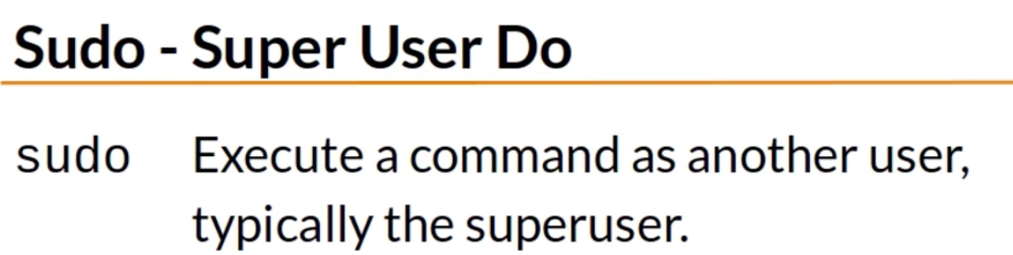

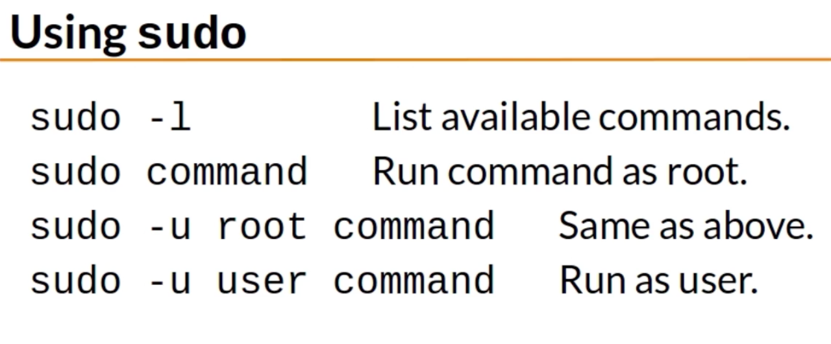

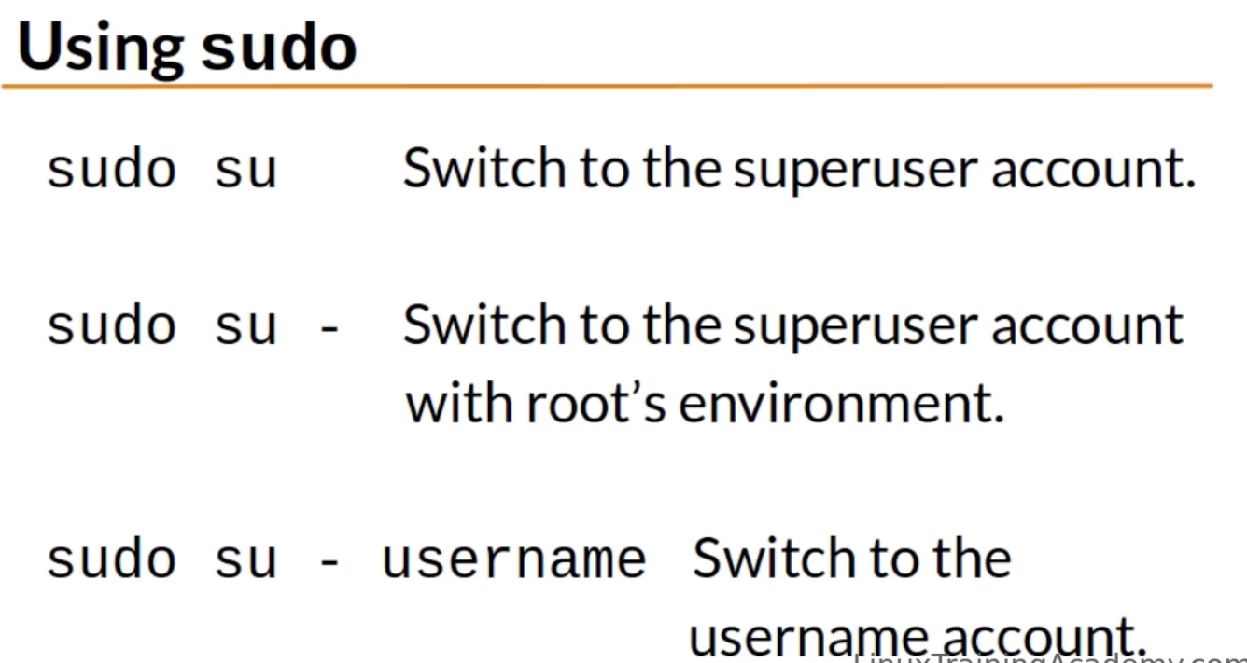

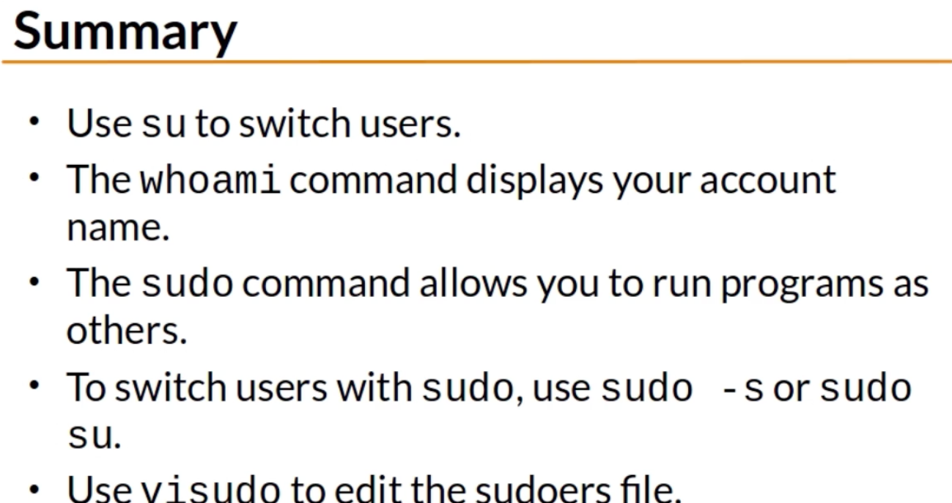

SHELL HISTORY AND TAB COMPLETION

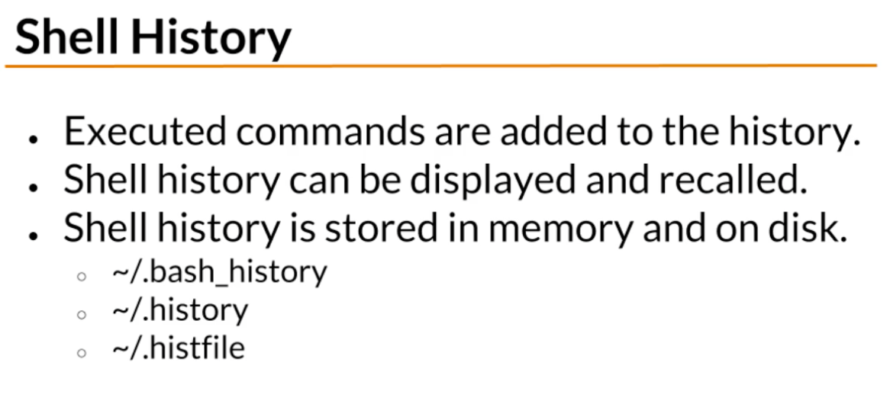

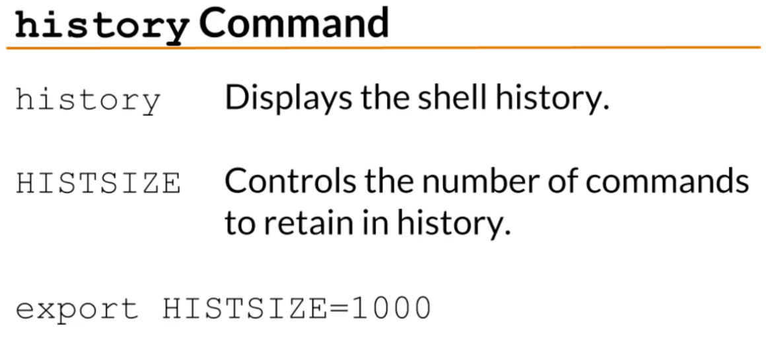

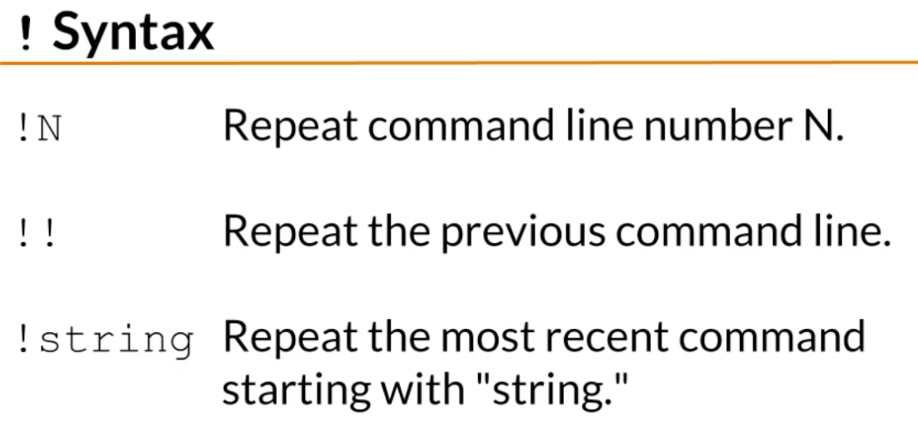

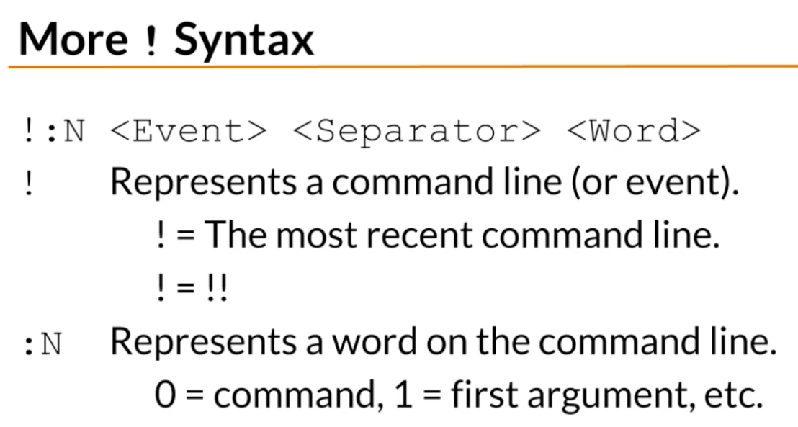

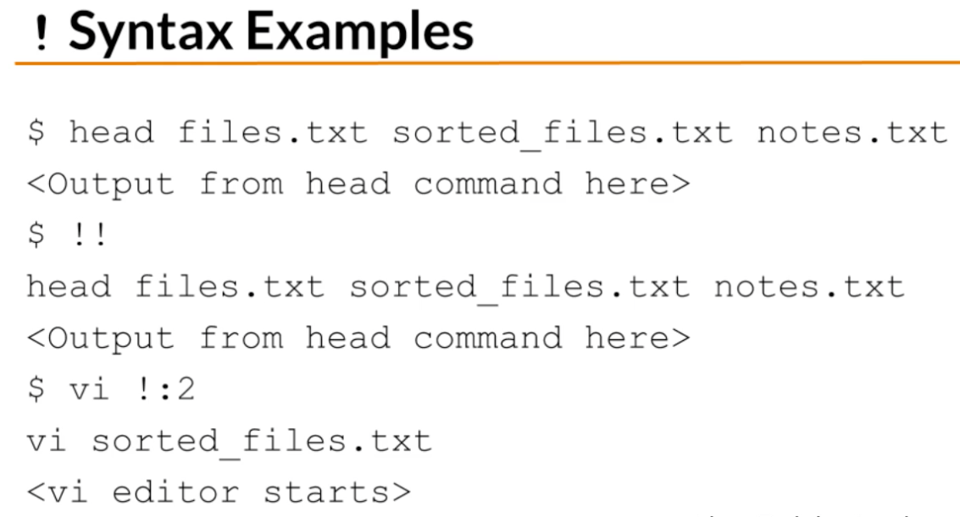

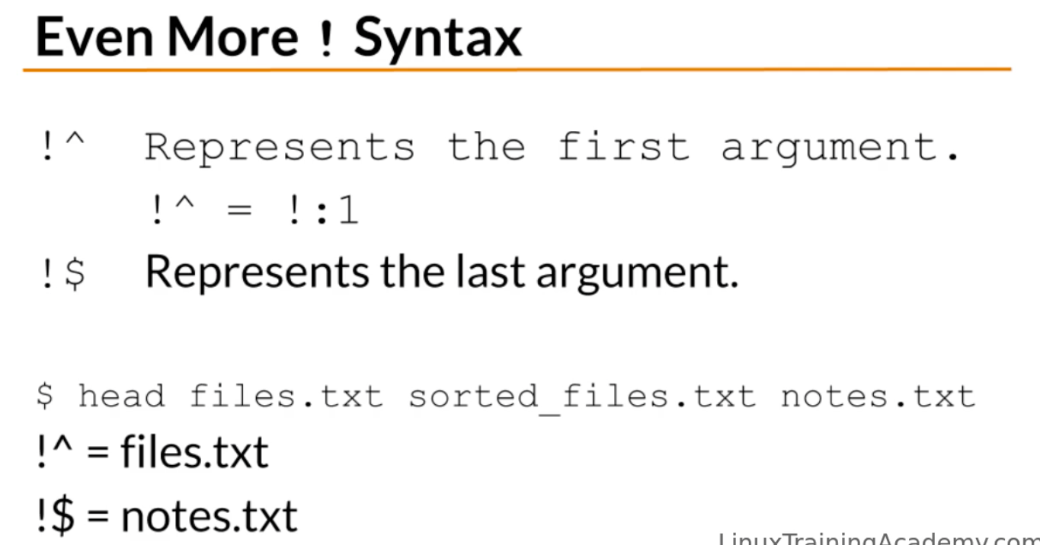

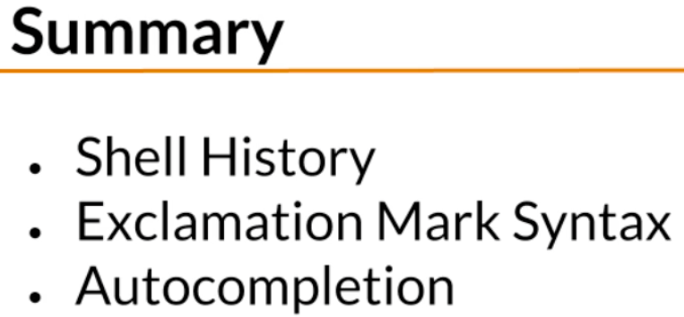

INSTALLING SOFTWARE

